**1. If I find Covariance between same variable what will be the output? What will be**

**correlation coefficient?**

**Solution # 1:**

**2. Assume I have a set of numbers. The mean, median and mode of the set of numbers are**

**equal. If I draw a Frequency plot of individual distinct numbers, how would the plot look**

**like?**

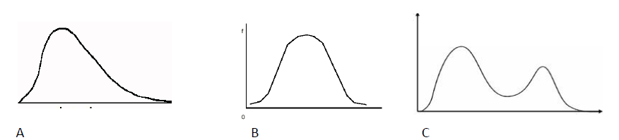

**Solution # 2:**